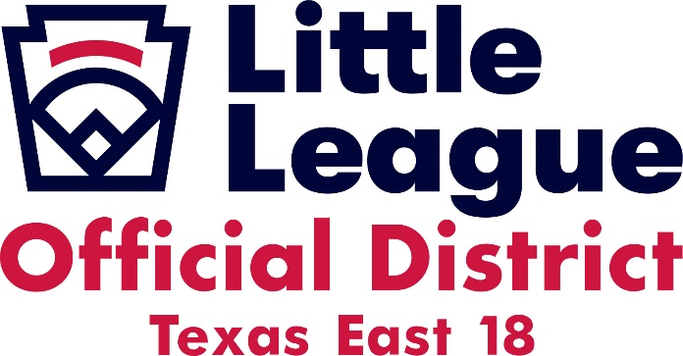

To all Sectional Winners of the 8 -10, 9-11, Little League Major, Junior League and Senior League:

Congratulations on winning your Sectional Tournament to advance to Texas East State Tournament in El Campo!

As the District Administration for the Little League District 18 of Texas East and the host of this year’s State Tournament, I would like to welcome all the players. I would also like to invite all your parents and friends to come to the tournament and enjoy the Opening Ceremonies. We are asking that all teams please bring a dozen (12) balls to the tournament with your books. Please have the managers return the roster form as soon as possible to get an accurate list of all participants for the announcers.

We are asking that you email a team picture with a list of all player names for the program as soon as you know the winners. This will be a great souvenir for all the teams that are present. Please email these to asanders@swbell.net.

El Campo Little League will have T-Shirts available at the site for sale during the games, so make sure you stop by to purchase one of the great looking shirts. All teams will be listed on the back, a great way to remember your time at the state tournament.

Once schedules are determined we will be issuing a batting cage schedule. Your team will be assigned times that the batting cages will be available to be used. Please follow the schedule to ensure that all teams have a chance to use the cages.

Please feel free to reach out with any questions or concerns, as my staff and I are available to help.

Thank You and Congratulations,
Paul Sanders
Cell 979-541-6630
sb-umpire@swbell.net
Little League Baseball Inc.
District Administrator
District 18
Texas East Section 4

